Integrantes del equipo
Matrícula | Nombre | Programa | Foto
2144053 | Lozano Garza Camila del Carmen | IAS | 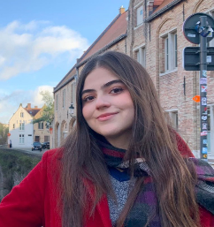
2160859 | Vera Moreno Oscar Elias | ITS | 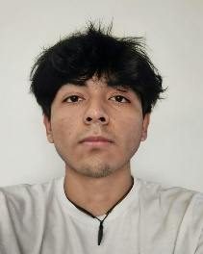
2226699 | Sánchez Santiago Osmar Abdi | ITS | 
2178081 | Cisneros Moreno Valeria Nohemí | ITS | 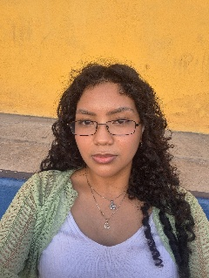
2144813 | Torres Guerrero David Alonso  (lider) | ITS | 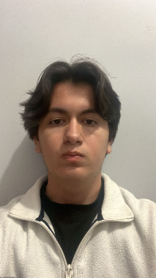
2161066 | Ramirez Fabian Maria de los Angeles | IAS | 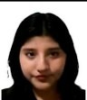
2169669 | Sánchez Juárez Emiliano | ITS | 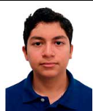
2097304 | Jaime Sebastian Esparza Leyva | ITS | 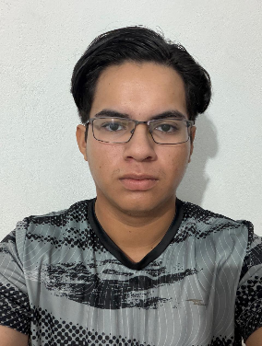
2158392 | Martinez Tamez Julio César | IAS | 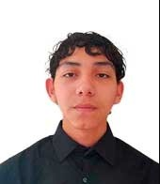
1320176 | Maycott  López  Gilberto | IAS | 